1. Quiz: Star Network

A Star Network has a single node in the center that is connected to all the rest of the nodes in the graph directly.

# Write a program that returns the number of edges

# in a star network that has `n` nodes

def star_network(n):

# return number of edges

if n < 2:

return 0

return n - 1

for x in range(5):

print(x, star_network(x))

1. Quiz: Recurrence Relation

Start with template. T(1) = 0; T(n) = 2*T(n/2)

Answer = Theta(n)

1. Quiz: Subsets

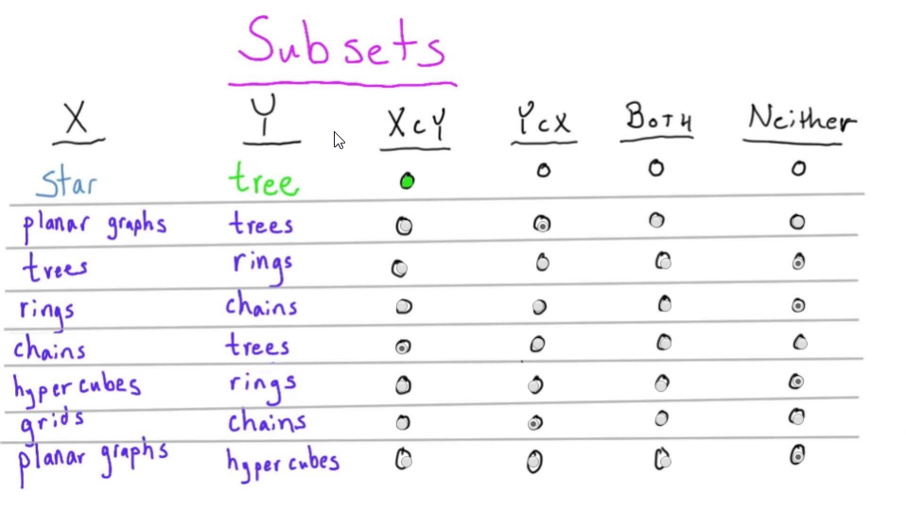

1. Quiz: Function Comparison

Big Theta n^2, Big-Oh n^2, Big-Oh n^3

1. Quiz: Planar Graphs

8 nodes, 15 connections, 9 regions.

8-15+9=2

1. Quiz: Combination Locks

Big-Theta(n)

1. Quiz: Make A Combination Lock
2. Quiz: Erdos-Renyi